Invitation
Dear International Guests,
The Welcome Centre of the Friedrich-Alexander-Universität Erlangen-Nürnberg is again hosting an

International Barbecue

on Wednesday, July 22nd 2015, starting at 5:30 p.m.

at the garden of“Internationales Begegnungszentrum”

(Erwin-Rommel-Straße 61, Erlangen)

You will have the opportunity to meet fellow international scholars and their hosts and we cordially invite you, your family, and your host to attend this evening. Please also inform your academic host about this invitation. The Vice-President for International Affairs, Prof. Dr. Günter Leugering and Dr. Elisabeth Preuß will also be present and are looking forward to meeting you.

We will provide beverages, salads, sausages and steaks (pork!) as well as vegetarian spits for a small charge. You may also bring your own barbecue meat.
In case of rain, do not worry. The event will take place under a tent, in any weather.
To confirm your attendance, please write an e-mail to jernej.ahc.ahcin@fau.de before July 17th.
We are looking forward to seeing you there!
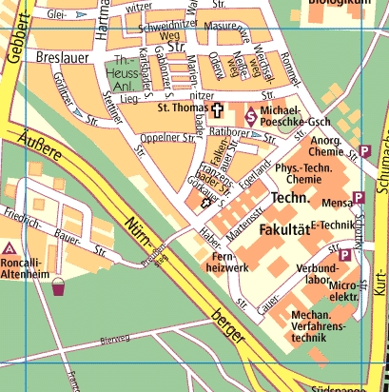

Internationales Begegnungszentrum (Erwin –Rommel-Straße 61, Erlangen)

