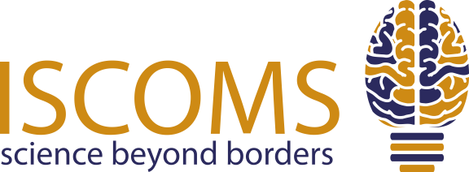
Dear student,

Are you conducting (bio)medical research and are you interested in presenting your work on an international platform? Or are you simply interested in learning about the latest (bio)medical research?

The International Student Congress Of (bio)Medical Sciences (ISCOMS) is one of the world’s leading student congresses in the field of (bio)medical sciences. Last year, 959 participants from more than 50 countries attended the 25th edition of ISCOMS. This year, the 26th edition will take place from the 3rd until the 7th of June 2019 in Groningen.

Students can visit the congress both as a presenting and non-presenting participant. ISCOMS offers a scientific programme with a pre-course on mastering your research, student presentation sessions (plenary, oral, and poster), workshops and a surgical operation. You can also acquire information on working and performing research in Groningen during our networking lunch, which gives you the opportunity to integrate with companies interested in recruiting ambitious biomedical students.

Moreover, students can explore PhD opportunities at the University Medical Center Groningen (UMCG) with our ISCOMS Research Fellowships (IRF). The IRF are a challenging two week programme in which students are expected to actively participate in research at one of the UMCG’s Research Institutes and gather a great deal of knowledge related to the topic of research. As a student, you get the chance to perform research at a leading institute, meet top-researchers, and – more importantly – learn about the possibilities of doing a PhD-programme in the Netherlands. There have been many foreign students who were able to start a PhD-programme in the UMCG due to the IRF. The IRF are available for presenting participants only.

On top of all this, we will feature an exciting social programme, including a formal dinner, the amazing World Wide ISCOMS Night and a Post Congress Tour.

CALL FOR ABSTRACTS
Are you interested in presenting your research at ISCOMS? Send in your abstract! The abstract submission will be open from the 29th of October till the 7th of February 2019. Each student is allowed to submit up to 2 abstracts. Abstracts can be submitted on our website www.iscoms.com.

For more information, please visit our website and Facebook page: www.facebook.com/iscoms, or check out our after movie from ISCOMS 2018: www.tinyurl.com/ISCOMS2018aftermovie. If you have any questions, feel free to contact us at iscoms@umcg.nl.

Kind regards,

Ellis van Can
International Contacts
ISCOMS 2019

